**The Power of Data in Data Science 🚀**



👋 Hello, everyone! I’m **Chitturi Durga Satya Sai Kiran**, a passionate Data Science enthusiast. As a versatile developer with experience in Full Stack Development and a fervent interest in Data Science, I’m thrilled to delve into the transformative power of data in this blog. Throughout this post, I’ll emphasize that **data isn’t just information; it’s the heartbeat of data science,** fueling innovation, uncovering hidden insights, and guiding informed decisions. 🚀

**Data: The Fuel of Data Science ⛽️**

*Data is the lifeblood of data science. It’s the raw material that we use to build models, extract insights, and ultimately make informed decisions. 🧠*

**But what exactly is data? 🤔**

Data is a collection of facts, figures, and symbols that represent information about a particular subject or phenomenon. 📊 It can be anything from numbers and text to images and videos.

In data science, data is used to:  
**Uncover hidden patterns and trends:**🔍 Data can reveal insights that we might not have noticed otherwise. By analyzing large datasets, we can identify patterns, correlations, and anomalies that can help us understand complex phenomena.

import pandas as pd  
  
# Load data  
data = pd.read_csv('data.csv')  
  
# Analyze data  
insights = data.describe()  
print(insights)

**Make better predictions:** 🔮 Data can be used to train machine learning models that can predict future events or outcomes. This can be used for a variety of purposes, such as forecasting sales, identifying fraud, or predicting customer churn.

from sklearn.model_selection import train_test_split  
from sklearn.linear_model import LinearRegression  
  
# Split data into training and testing sets  
X_train, X_test, y_train, y_test = train_test_split(X, y, test_size=0.2, random_state=42)  
  
# Train the model  
model = LinearRegression()  
model.fit(X_train, y_train)  
  
# Make predictions  
predictions = model.predict(X_test)

**Drive innovation and progress:**🚀 Data can be used to develop new products, services, and solutions that address real-world problems. By understanding the needs and wants of our customers, we can create solutions that improve their lives.

**Types of Data 📊**

There are many different types of data, but they can be broadly categorized into two main groups:

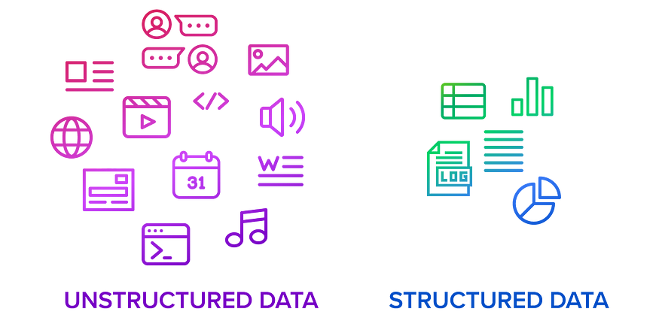

**Structured data:** *This type of data is organized in a predefined format, such as rows and columns in a spreadsheet or database table. Examples of structured data include customer records, financial transactions, and sensor readings.*

**Unstructured data:***This type of data is not organized in a predefined format. Examples of unstructured data include text documents, images, videos, and social media posts.*

**Data Science Techniques 🧰**

Data scientists use a variety of techniques to analyze and interpret data. Some of the most common techniques include:

M**achine learning:** *This is a type of artificial intelligence that allows computers to learn from data without being explicitly programmed. Machine learning can be used for a variety of tasks, such as classification, regression, and clustering.*

S**tatistical analysis:** *This is a branch of mathematics that deals with the collection, analysis, interpretation, and presentation of data. Statistical analysis can be used to identify patterns, trends, and relationships in data.*

D**ata visualization:***This is the process of creating visual representations of data, such as charts, graphs, and maps. Data visualization can help us to understand complex data more easily.*



**Tools for Handling Data 🛠️**

There are many different tools available for handling data. Some of the most popular tools include:

**Programming languages:***Python, R, and SQL are the most popular programming languages used in data science.*

**Data analysis tools:***Pandas, NumPy, and Scikit-learn are popular Python libraries for data analysis.*

**Cloud computing platforms:***Amazon Web Services (AWS), Microsoft Azure, and Google Cloud Platform (GCP) offer a variety of cloud-based data storage and analysis services.*

**Resources for Getting Data 📚**

There are many different sources of data available to data scientists. Some of the most common sources include:

**Public datasets:***There are many public datasets available online, such as the UCI Machine Learning Repository and the Kaggle Datasets.*

**Government data:***Governments around the world collect a vast amount of data, which is often made available to the public.*

**Private companies:***Many private companies collect data on their customers and operations, which they may be willing to share with data scientists.*

**The Future of Data in Data Science 🔮**

The future of data in data science is bright. As we continue to collect and analyze more data, we’ll unlock even more insights and opportunities to improve our world.



Here are some of the trends that we can expect to see in the future of data science:

**The rise of artificial intelligence (AI):**AI is already playing a major role in data science, and its role is only going to grow in the future. AI-powered tools will make it easier for data scientists to analyze large datasets and extract insights.

**The increasing importance of data ethics:** As we collect and analyze more data, it’s important to ensure that we are doing so ethically. Data scientists will need to be aware of the potential risks of data misuse and take steps to mitigate them.

**The growing demand for data scientists:** The demand for data scientists is already high, and it is only going to grow in the future. This is a great opportunity for people who are interested in a career in data science.

**Resources 📚**

Here are some resources that you may find helpful:

* Kaggle: <https://www.kaggle.com/>
* DataCamp: <https://www.datacamp.com/>
* Coursera: <https://www.coursera.org/>
* Udacity: <https://www.udacity.com/>
* UCI Machine Learning Repository: <https://archive.ics.uci.edu/ml/index.php>
* Kaggle Datasets: <https://www.kaggle.com/datasets>
* Python: <https://www.python.org/>
* R language: [https://www.](https://www.r-project.org/)r-project[.org/](https://www.r-project.org/)
* Machine learning: <https://www.coursera.org/learn/machine-learning>
* Pandas: <https://pandas.pydata.org/>
* NumPy: <https://numpy.org/>
* Scikit-learn: <https://scikit-learn.org/>
* AWS: <https://aws.amazon.com/>
* Azure: <https://azure.microsoft.com/>
* GCP: <https://cloud.google.com/>

**Data**is the **guiding light of data science**, illuminating the path to insights and innovation. 🔦 It’s the compass that helps us navigate the complexities of our world, revealing hidden patterns and driving progress. As we venture further into the data-driven future, the importance of data will only intensify. **Those who can harness its power will be the architects of a better tomorrow.**So, let’s embrace the power of data and use it to illuminate the path to a brighter future for all. 🌎

**Now, it’s your turn:**What are your thoughts on the power of data in data science? Have you had any experiences where data has transformed your understanding or decision-making process? Share your insights and join the conversation in the comments section below. Let’s continue to learn and grow together in the fascinating world of data science!

Your support means a lot to me, so please consider following

[Chitturi Durga Satya Sai Kiran](https://medium.com/u/dc5024be7300?source=post_page-----4c4973232906--------------------------------)

 and giving the article 50 claps 😅 if you find it informative and enjoyable.

Thank you for your time and Happy reading!

[Data](https://medium.com/tag/data?source=post_page-----4c4973232906---------------data-----------------)

[Data Science](https://medium.com/tag/data-science?source=post_page-----4c4973232906---------------data_science-----------------)

[Data Visualization](https://medium.com/tag/data-visualization?source=post_page-----4c4973232906---------------data_visualization-----------------)

[Data Analysis](https://medium.com/tag/data-analysis?source=post_page-----4c4973232906---------------data_analysis-----------------)

[Importance Of Data](https://medium.com/tag/importance-of-data?source=post_page-----4c4973232906---------------importance_of_data-----------------)